# Archer Conflict of Interest Management

Conflicts of interest exist throughout the commercial world. They are a particularly important challenge for large and complex financial institutions, which can have affiliations that lead to a host of potential conflicts of interest. When not carefully managed, these conflicts can lead to failure to protect the customer or organization’s interests and regulatory or reputation risks that could be disastrous for all included parties.  A conflict of interest is a scenario in which a person or organization has an incentive to serve one's interest at the expense of the other.  It might mean serving the interest of the organization over that of a customer or serving the interest of one customer over other customers, or an employee or group of employees serving their own interests over those of the organization or its customers.

On this page

* Release history
* Release notes
  + Release 6.11
    - New and changed features
* Overview of Archer Conflict of Interest
  + About Archer Conflict of Interest
  + Key features and benefits
  + Prerequisites (ODA and system requirements)
  + Compatible Use Cases and Applications
    - Related Applications
* Archer Conflict of Interest components
  + Architecture diagram
  + Swim Lane diagram
  + Applications
  + Personas and Access Roles
  + Permissions chart
* Installing Archer Conflict of Interest
  + Installation overview
    - Task 1: Prepare for the installation
    - Task 2: Install the package
    - Task 3: Set up data feeds
    - Task 4: Test the installation
  + Installing the package
    - Task 1: Back up your database
    - Task 2: Import the package
    - Task 3: Map objects in the package
    - Task 4: Install the package
    - Task 5: Review the package installation log
* Configure additional features for Archer Conflict of Interest
  + (Optional) Configure Archer Engage for new Conflict of Interest submission
  + (Optional) Enable actions by email for COI approver
* Upgrading Archer Conflict of Interest
* Using Archer Conflict of Interest
  + Task 1: Create a new request
  + Task 2: Perform risk assessment
  + Task 3: Reviewing the request
  + Task 4: Create a mitigation plan
  + Task 5: Reassign approver
  + Task 6: Resubmitting a request
  + Task 7: Archive and reassess
* Certification environment

## Release history

Last updated: November 2022

## Release notes

### Release 6.11

#### New and changed features

| Component | Description |
| --- | --- |
| Dashboards | 1. Updated COI Owner and COI Approver dashboards to utilize latest reporting features and reduce clutter |
| Application | 1. New updates for Archer Engage portal integration 2. Provided custom object for publishing conflict of interest template to Archer Engage portal. 3. Few field and layout changes were made. |

## Overview of Archer Conflict of Interest

### About Archer Conflict of Interest

Some common scenarios of Conflict of Interest include:

* Outside Board Membership, Industry Associations, and Advisory Committees
* Secondary Employment and Outside Business Interest
* Financial Interests
* Personal Workplace Relationships
* Relationships with Suppliers, Partners and Other Third Parties
* Gifts and Hospitality

As new products, services, and marketing strategies evolve to meet changing customer needs and market conditions, organizations need to be disciplined in continually searching for new conflicts of interest and working through how to address them. In addition, approaches to remediating existing conflicts of interest may also require regular reconsideration as circumstances change.

The Archer Conflict of Interest Management solution helps organizations to track and perform assessments against conflicts of interest and monitor exception requests and remediation plans to address conflicts of interest that may pose a risk to the organization.

### Key features and benefits

The Archer Conflict of Interest offering enables organizations to:

* Track conflicts of interest internal and external to the organization
* Perform risk assessment against potential conflicts of interest
* Document outcome, issues, and action plans to address conflicts of interest
* Monitor and review action plans and conflicts of interest

Benefits include:

* Consistent and repeatable process for managing relationships with conflicts of interest
* Insight into employee and business relationships that pose a risk to the organization through a conflict of interest
* Prioritization of risk for conflict of interest action plans

### Prerequisites (ODA and system requirements)

| Components | Prerequisites |
| --- | --- |
| Archer Solution Area(s) | Archer Regulatory & Corporate Compliance Management |
| Archer Use Case(s) | Archer Issues Management |
| Archer Applications | Requirements for the installation and operation of Archer Conflict of Interest includes the following use cases:   * Exception Requests– (Archer Issues Management) * Remediation Plans– (Archer Issues Management) |
| Uses Custom Application | Yes |
| Requires On-Demand License | Yes. The Archer Conflict of Interest Management App-Pack requires one (1) On-Demand Applications license and one (1) Questionnaire. |
| Archer Requirements | Archer 6.11 and later |

### Compatible Use Cases and Applications

#### Related Applications

| Application | Use Case | Primary Purpose(s) of the Relationship |
| --- | --- | --- |
| Business Unit | Archer Issues Management, Archer Business Impact Analysis, Archer Third Party Catalog, Archer IT Asset Catalog, Archer Business Asset Catalog, Archer Key Indicator Management | * To relate Business Units that are impacted by the conflict of interest |
| Third Party Profile | Archer Third Party Catalog | * To associate and track conflicts against third party and their profile. |
| Contacts | Archer Audit Engagements and Workpapers, Archer Incident Management, Archer Third Party Catalog, Archer IT Asset Catalog, Archer Data Governance, Archer Business Asset Catalog, Archer Loss Event Management, Archer Self-Assessment Management | * To associate and track conflicts against Employees or other contacts. |
| Policies | Archer Policy Program Management | * To relate violated policies to the conflicts. |
| Findings | Issues Management | * To relate any findings in assessment. |
| Speak Up | Archer Speak Up App-pack | * To submit conflicts anonymously and track them. |
| Gift Registry | Archer Gift Registration | To relate supporting Gift Registry requests |

## Archer Conflict of Interest components

### Architecture diagram

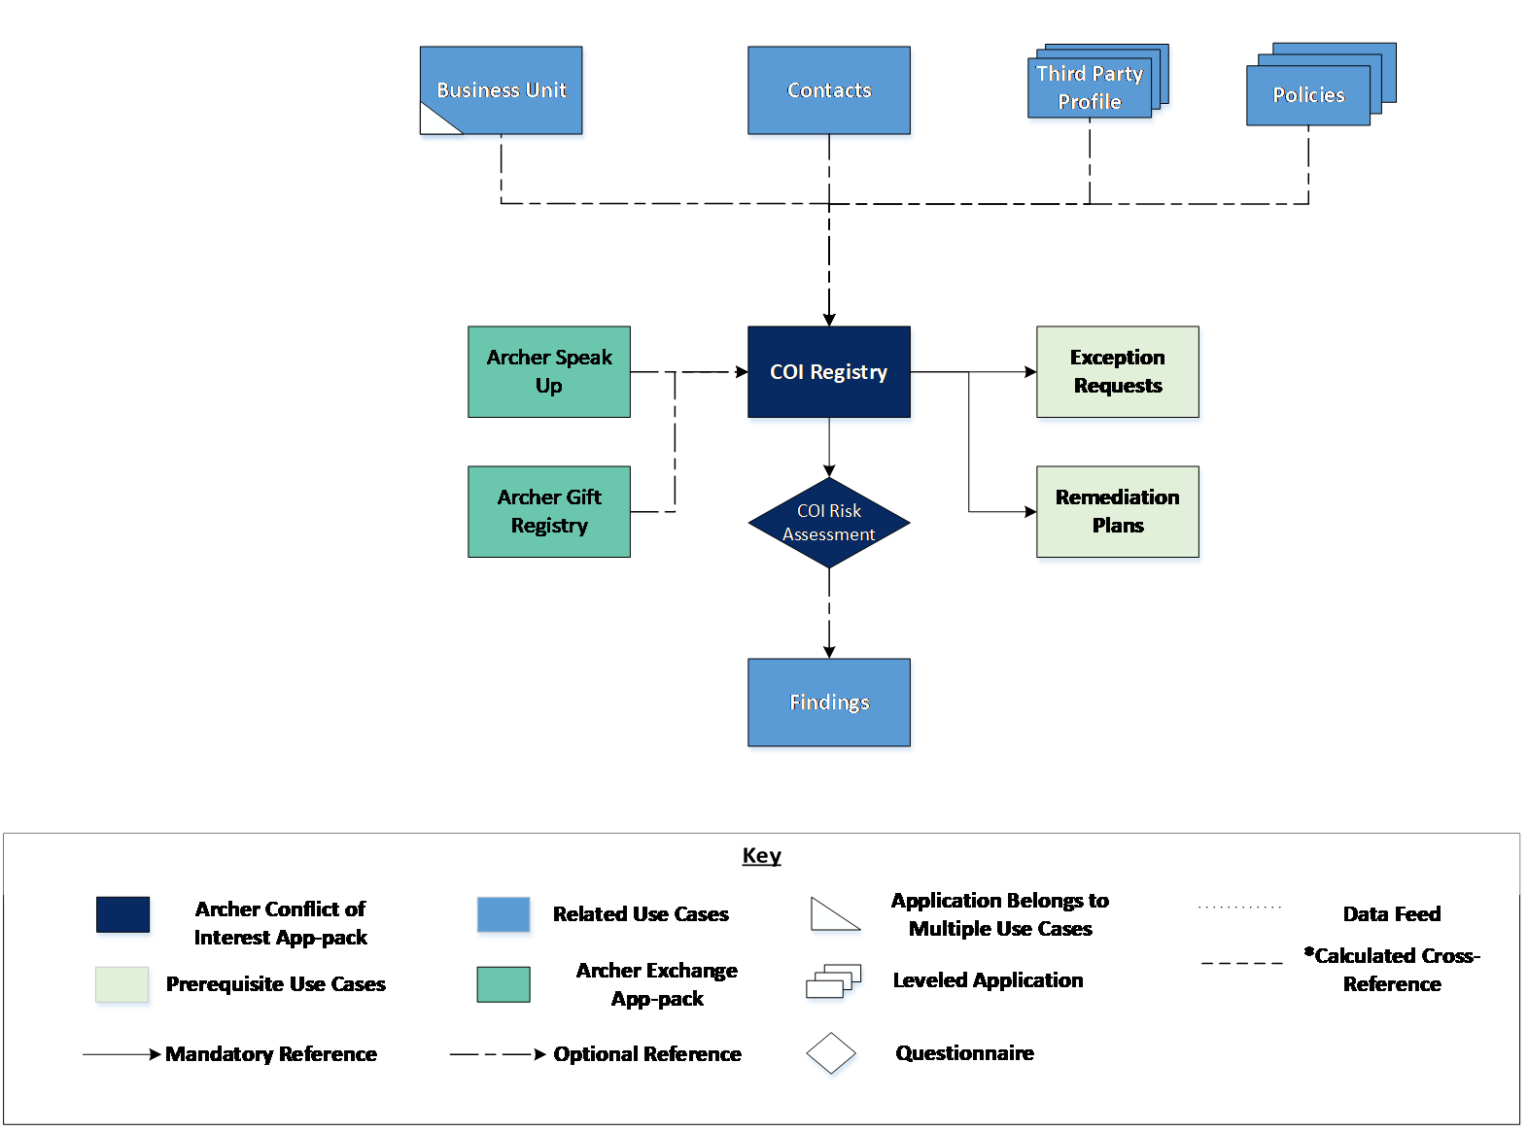

### Swim Lane diagram

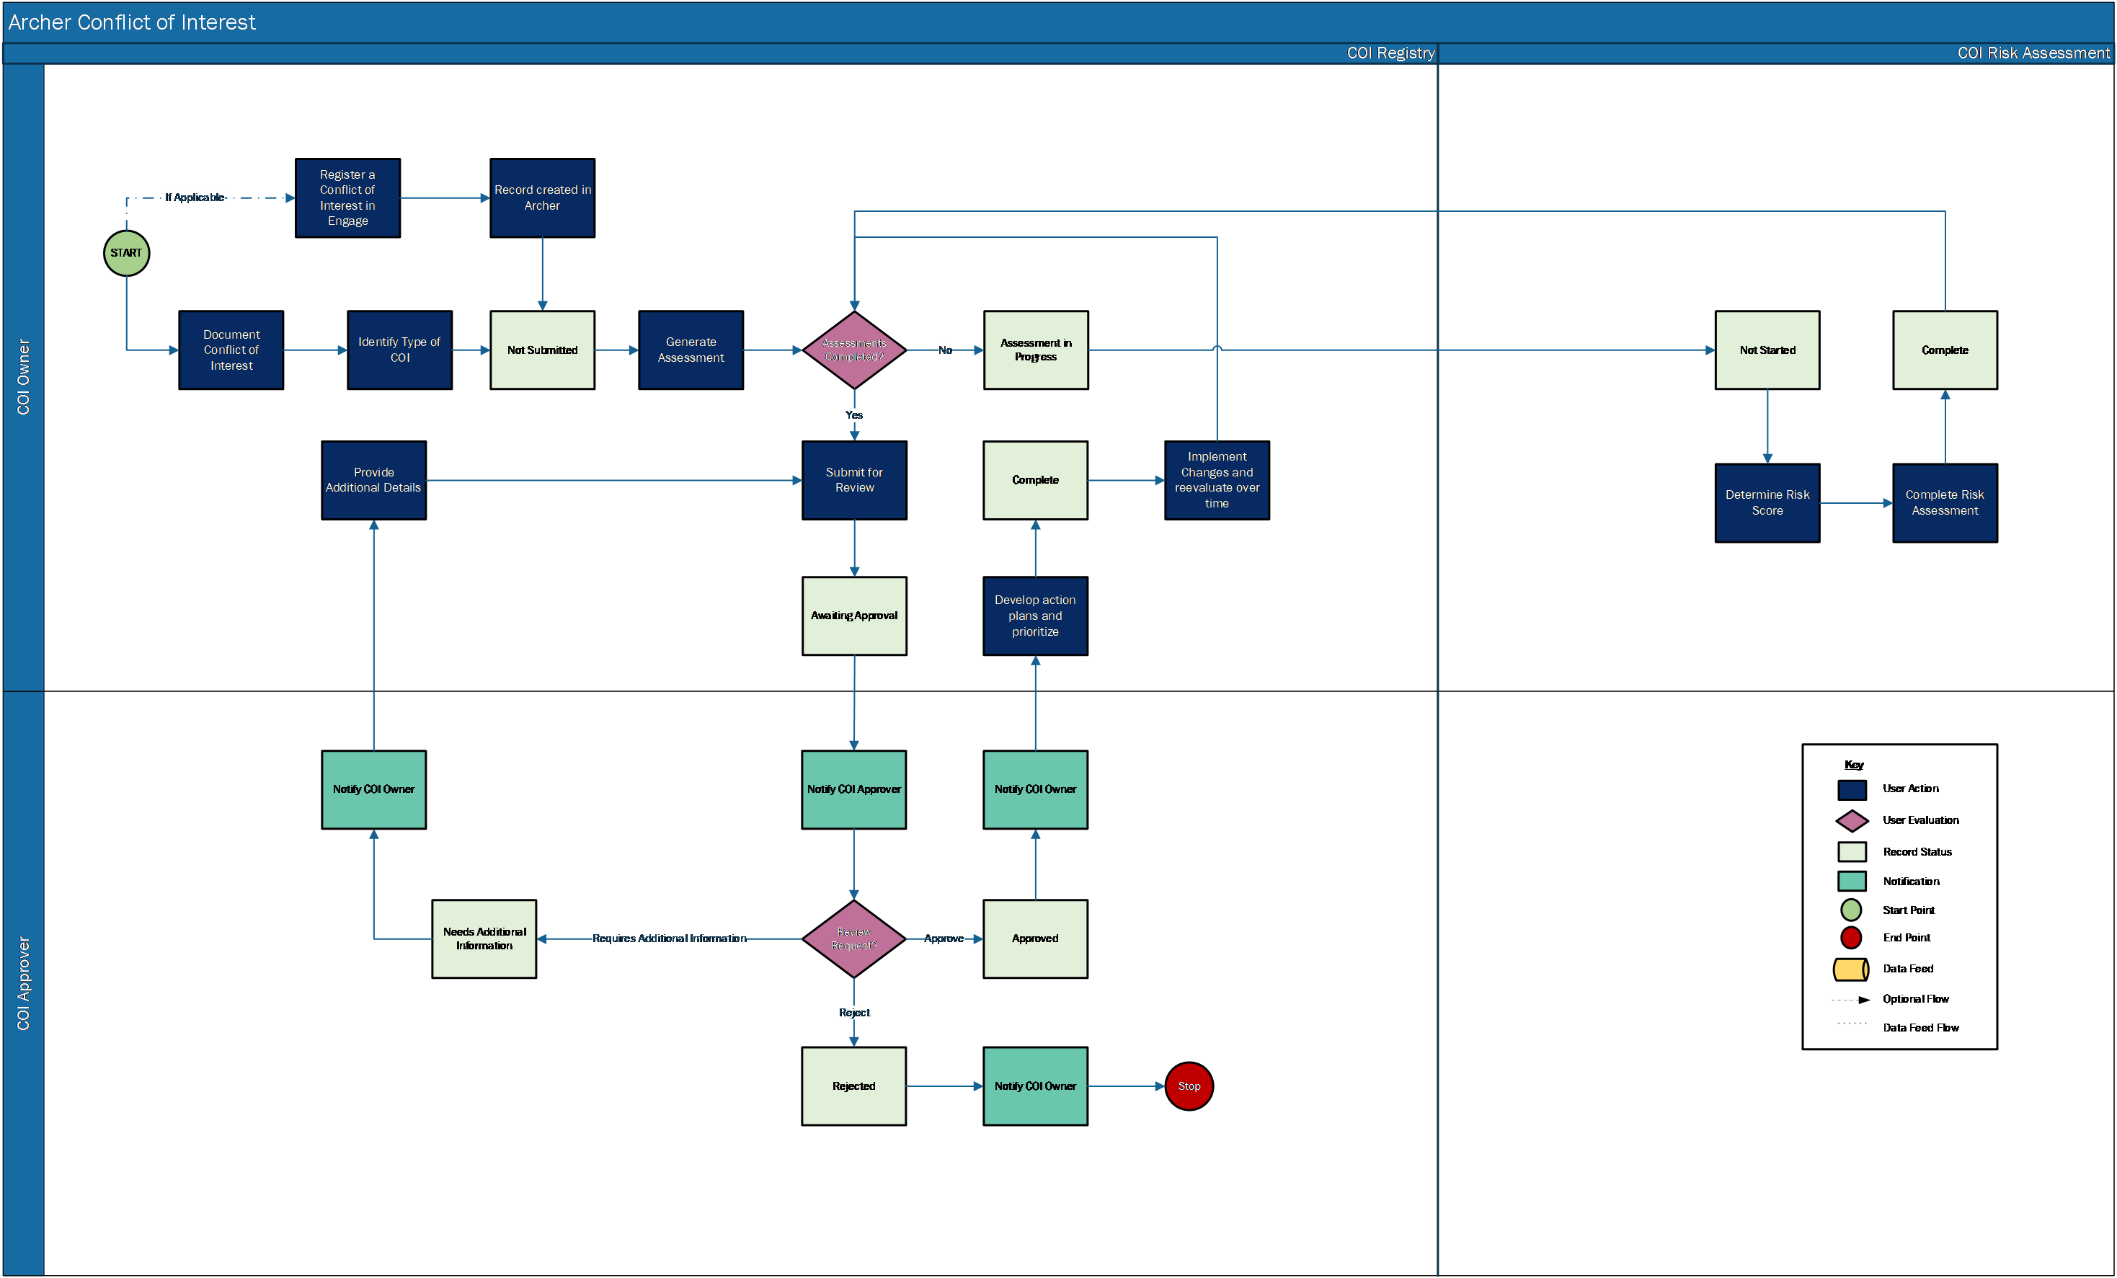

### Applications

The following table describes the applications in Archer Conflict of Interest Management.

| Application | Description |
| --- | --- |
| COI Registry | The COI Registry application documents all the information regarding potential conflicts of interest. It captures the results from the assessment, the approval, remediation plans or exception requests, and supporting information. |
| COI Risk Assessment | The COI Risk Assessment is a questionnaire used to determine the likelihood and impact of the conflict of interest and the results. |

### Personas and Access Roles

The following table describes the functions that make up the application’s organization roles. Depending on the organization of your company, these functions and responsibilities may vary.

| Function | Description |
| --- | --- |
| COI Owner | The Conflict of Interest Owner is responsible for identifying, assessing, and determining conflicts of interest. They also track the mitigation plans and reassess conflicts of interest as needed. This person is typically someone in the compliance or ethics management department. |
| COI Approver | The Conflict of Interest Approver is responsible for reviewing and approving conflicts of interest. They oversee the Conflict of Interest management process and monitor the Conflicts of Interest for high risk conflicts of interest and escalate the mitigation plan. This person is typically a manager in the compliance or ethics management department. |

### Permissions chart

| COI Registry | CRU* | R |
| --- | --- | --- |
| COI Risk Assessment | CRU* | RU* |
| Gift Registry | R | R |
| Speak Up | R | R |
| Business Units | R | R |
| Policies | R | R |
| Third Party Profile | R | R |
| Contacts | R | R |
| Remediation Plans | CRU* | R |
| Exception Requests | CRU* | R |

C = Create, R = Read, U = Update, D = Delete

**Note:** Members of the Owner, Approver groups should also be assigned to the EM: Read Only, PM: Read Only and Third Party: Read Only groups under Enterprise Management, Policy Management and Third Party Risk Management to allow selection of Business Unit, Policies and Third Party Profiles.

## Installing Archer Conflict of Interest

### Installation overview

Complete the following tasks to install the offering.

#### Task 1: Prepare for the installation

1. Ensure that your Archer system meets the following requirements:
   * Archer Platform version 6.11 or later.
2. Obtain the Data Dictionary for the ODA by contacting your Archer Account Representative. The Data Dictionary contains the configuration information for the use case.
3. Read and understand the "Packaging Data" section of Archer Help.

#### Task 2: Install the package

Installing a package requires that you import the package file, map the objects in the package to objects in the target instance, and then install the package. See Installing the Application Package for complete information.

#### Task 3: Set up data feeds

You must import and schedule each use case data feed that you want to use. See Setting Up Data Feeds for complete information.

#### Task 4: Test the installation

Test the application according to your company standards and procedures, to ensure that the use case works with your existing processes.

### Installing the package

#### Task 1: Back up your database

There is no Undo function for a package installation. Packaging is a powerful feature that can make significant changes to an instance. Archer strongly recommends backing up the instance database before installing a package. This process enables a full restoration if necessary.

An alternate method for undoing a package installation is to create a package of the affected objects in the target instance before installing the new package. This package provides a snapshot of the instance before the new package is installed, which can be used to help undo the changes made by the package installation. New objects created by the package installation must be manually deleted.

#### Task 2: Import the package

1. Go to the Install Packages page.
   1. From the menu bar, click .
   2. Under Application Builder, click Install Packages.
2. In the Available Packages section, click Import.
3. Click Add New, then locate and select the package file that you want to import.
4. Click OK.

The package file is displayed in the Available Packages section and is ready for installation.

#### Task 3: Map objects in the package

**Important:** This step is required only if you are upgrading to a later version of [ODA name].

1. In the Available Packages section, select the package you want to map.
2. In the Actions column, click  for that package.

The analyzer runs and examines the information in the package. The analyzer automatically matches the system IDs of the objects in the package with the objects in the target instances and identifies objects from the package that are successfully mapped to objects in the target instance, objects that are new or exist but are not mapped, and objects that do not exist (the object is in the target but not in the source).

**Note:** This process can take several minutes or more, especially if the package is large, and may time out after 60 minutes. This time-out setting temporarily overrides any IIS time-out settings set to less than 60 minutes.

When the analyzer is complete, the Advanced Package Mapping page lists the objects in the package file and corresponding objects in the target instance. The objects are divided into tabs, depending on whether they are found within Applications, Solutions, Access Roles, Groups, Sub- forms, or Questionnaires.

1. On each tab of the Advanced Mapping Page, review the icons that are displayed next to each object name to determine which objects require you to map them manually.

| Icon | Name | Description |
| --- | --- | --- |
| Awaiting mapping review | Awaiting Mapping Review | Indicates that the system could not automatically match the object or children of the object to a corresponding object in the target instance.  Objects marked with this symbol must be mapped manually through the mapping process.  **Important:** New objects should not be mapped. This icon should remain visible. The mapping process can proceed without mapping all the objects.  **Note:** You can execute the mapping process without mapping all the objects. The Awaiting mapping review icon is for informational purposes only. |
| Checkmark | Mapping  Completed | Indicates that the object and all child objects are mapped to an object in the target instance. Nothing more needs to be done with these objects in Advanced Package Mapping. |
| Missing objects | Do Not  Map | Indicates that the object does not exist in the target instance or the object was not mapped through the Do Not Map option. These objects will not be mapped through Advanced Package Mapping, and must be remedied manually. |
|  | Undo | Indicates that a mapped object can be unmapped. This icon is displayed in the Actions column of a mapped object or object flagged as Do Not Map. |

1. For each object that requires remediation, do one of the following:
   * To map each item individually, on the Target column, select the object in the target instance to which you want to map the source object. If an object is new or if you do not want to map an object, select Do Not Map from the drop-down list.
   * **Important:** Ensure that you map all objects to their lowest level. When objects have child or related objects, a drill-down link is provided on the parent object. Child objects must be mapped before parent objects are mapped. For more details, see "Mapping Parent/Child Objects" in Archer Help.
   * To automatically map all objects in a tab that have different system IDs but the same object name as an object in the target instance, do the following:
2. In the toolbar, click Auto Map.
3. Select an option for mapping objects by name.

| Option | Description |
| --- | --- |
| Ignore case | Select this option to match objects with similar names regardless of the case of the characters in the object names. |
| Ignore spaces | Select this option to match objects with similar names regardless of whether spaces exist in the object names. |

1. Click OK.

* The Confirmation dialog box opens with the total number of mappings performed. These mappings have not been committed to the database yet and can be modified in the Advanced Package Mapping page.

1. Click OK.

* To set all objects in the tab to Do Not Map, in the toolbar, click Do Not Map.

**Note:** To undo the mapping settings for any individual object, click  in the Actions column.

When all objects are mapped, the Checkmark icon is displayed in the tab title. The Missing objects icon is displayed next to the object to indicate that the object will not be mapped.

1. Verify that all other objects are mapped correctly.
2. (Optional) To save your mapping settings so that you can resume working later, see"Exporting and Importing Mapping Settings" in Archer Help.
3. Once you have reviewed and mapped all objects, click .
4. Select I understand the implications of performing this operation and click OK.

The Advanced Package Mapping process updates the system IDs of the objects in the target instance as defined on the Advanced Package Mapping page. When the mapping is complete, the Import and Install Packages page is displayed.

**Important:** Advanced Package Mapping modifies the system IDs in the target instance. Any Data Feeds and Web Service APIs that use these objects will need to be updated with the new system IDs.

#### Task 4: Install the package

All objects from the source instance are installed in the target instance unless the object can not be found or is flagged to not be installed in the target instance. A list of conditions that may cause objects not to be installed is provided in the Log Messages section. A log entry is displayed in the Package Installation Log section.

1. Go to the Install Packages page.
   1. From the menu bar, click Admin menu.
   2. Under Application Builder, click Install Packages.
2. In the Available Packages section, locate the package file that you want to install, and click Install.
3. In the Configuration section, select the components of the package that you want to install.
   * To select all components, select the top-level checkbox.
   * To install only specific global reports in an already installed application, select the checkbox associated with each report that you want to install.

**Note:** Items in the package that do not match an existing item in the target instance are selected by default.

1. In the Configuration section, under Install Method, select an option for each selected component. To use the same Install Method for all selected components, select a method from the top-level drop-down list.

**Note:** If you have any existing components that you do not want to modify, select Create New Only. You may have to modify those components after installing the package to use the changes made by the package.

1. In the Configuration section, under Install Option, select an option for each selected component. To use the same Install Option for all selected components, select an option from the top-level drop-down list.

**Note:** If you have any custom fields or formatting in a component that you do not want to lose, select Do not Override Layout. You may have to modify the layout after installing the package to use the changes made by the package.

1. To deactivate target fields and data-driven events that are not in the package, in the Post-Install Actions section, select the Deactivate target fields and data-driven events that are not in the package checkbox. To rename the deactivated target fields and data-driven events with a user-defined prefix, select the Apply a prefix to all deactivated objects check box, and enter a prefix. This can help you identify any fields or data-driven events that you may want to review for clean up post-install.
2. Click Install.
3. Click OK.

#### Task 5: Review the package installation log

1. Go to the Package Installation Log tab of the Install Packages page.
   1. From the menu bar, click .
   2. Under Application Builder, click Install Packages.
   3. Click the Package Installation tab.
2. Click the package that you want to view.
3. In the Package Installation Log page, in the Object Details section, click View All Warnings.
4. Manually activate Advanced Workflow by clicking Active button in Advanced Workflow tab in Archer COI Registry application.

## Configure additional features for Archer Conflict of Interest

### (Optional) Configure Archer Engage for new Conflict of Interest submission

Customers with Archer Engage enabled in their organization can configure Archer Conflict of Interest to allow new conflict submission through Archer Engage portal. Archer Engage should be of version 2.0.0 or above.

To know about Archer Engage visit [Archer Community](https://www.archerirm.community/t5/product-advisories/archer-announces-availability-of-archer-engage-release-v3-0-0/ta-p/685698).

Perform the following changes to configure and publish the conflict-of-interest template and generate the link for new conflict creation in Engage. This is a one-time action required to publish the link for new conflict of interest in Engage. These set of actions need to be performed by your Archer Administrator.

1. Open COI Registry application.
   1. From the menu bar, click Admin menu.
   2. Under Application Builder, click Applications.
   3. Under Applications, click COI Registry.
2. Edit Custom Object Publish Conflict of Interest Template
   1. In 001 Default Layout’s Designer Tab under Layout Objects “Publish COI Registration Form” custom object can be found.
   2. Click on custom object to Edit.
3. Update 006 Engage Layout: Under Layouts select 006 Engage Layout and update the layout with fields which you want to publish to the Engage. For supported field types, refer Archer Engage Documentation in [Archer Community](https://www.archerirm.community/t5/product-blogs/record-creation-in-archer-engage/ba-p/684415).
4. In the custom code update the following:
   1. Layout Id: Layout Id for “006 Engage Layout” in the Application. If you wish to publish a different layout, use that layout id. Layout id can be found in the Layout Properties in the Designer tab. Example: 568
   2. User Id: The numeric Id of the user to receive the initial New Record creation URL. You can obtain this from Access control > Users. Hover the mouse on the username. A numeric number would be displayed in the left corner of the page. Example: 210. This user must have an email defined.
   3. Email Access Config: Restrict the email domains which can receive the published link.
      1. Domains - Use to specify domains for access control. Provide your organization’s domain name. Example: archerirm.com
      2. Access Config - Use one of the following options to control access:
         1. Allow - Restricts record creation to the email domains listed in Domains. You must have at least 1 email listed in Domains.
         2. Deny - Denies record creation to those email domains listed in Domains. You must have at least 1 email listed in Domains.
         3. None - No restrictions.
   4. publish New Record Template URL: Use the URL for your Archer Engage Agent deployment. Example: '/engage/api/template/Publish'
5. Save the Custom Object.
6. Steps to Publish the link:
   1. Place the custom object on the default layout and save it.
      1. Place the custom object in an existing section if you wish to move it off-layout once the link is published.
      * OR
      1. Place the custom object in a new section. Create a DDE to hide it from all users except for administrators.
   2. Create a new conflict of interest record:
      1. From the menu bar, click Conflict of Interest.
      2. Under Solutions, click Conflict of Interest.
      3. Under Applications, click COI Registry.
      4. Click New Record.
   3. Click button “Publish Template”
   4. After publishing is complete the button message will change to “Publish Successful”. The email account of the user configured in the custom object will receive the link to create new conflict in Archer Engage portal.
   5. The custom object in application can be moved off-layout if required. If not, custom object should be hidden from all users and should be accessible to only administrators.
7. Update field logic for “Origin of COI” field: This field is set to Archer Engage Form by default. This field is set to No Selection via a data driven event if created manually. Current logic only assumes that data is only entered manually or through engage. If there are other external sources for the conflict (import/data feed input etc.) update the logic as per your configuration.
8. The published link can now be shared to the users to report new conflict of interest.

### (Optional) Enable actions by email for COI approver

Actions by email enables users to perform advance workflow actions from the email they receive from Archer. Customers can enable Actions by email for COI Approver Review. E-signature has been enabled for COI Approver. If users wish to enable Actions by Email E-Signature for COI Approver user action should be disabled. Actions by email needs to be enabled at multiple places before utilizing it:

1. Archer Control Panel: Advance Workflow Actions By Email Configuration should be enabled and  updated. You must configure the Archer Control Panel to allow for Actions by Email, see "Configuring Advanced Workflow Actions by Email" in the Archer Control Panel Help Documentation
2. Notification: Enable Actions by email in the on-demand notification template. An on-demand notification template is readily available on package installation.
3. COI Registry Application: Enable Actions By Email in the general tab, options section of the application.
4. COI Registry Advance Workflow:
   1. Disable E-Signatures for Approve transition.
   2. Enable in the COI Approver user action node and select action by email notificationtemplate.
   3. Remove any rules for transitions from COI Approver Action user action node. If any rules are present for a transition,  the respective workflow action cannot be taken from the email.
5. User Accounts: Enable in Account Maintenance section of the user account page. Ensure email id is configured for the user.

## Upgrading Archer Conflict of Interest

For the Conflict of Interest 6.11 release, the components have been updated to align with the 6.11 release changes. If you are upgrading from previous version to version 6.11 or later, be aware of the following changes.

**Note:**

* Upgrade customers are suggested to perform impact analysis due to the changes before performing the package installation.
* While installing the package please note that advanced workflow in your COI Registry application would be replaced with the advanced workflow from the package.
* If Override Layout(s) was selected in package selector for the components during package installation, layouts would be overridden.
* Upon package installation, iViews will not be removed from dashboard and Report will not be removed from iViews. This is a manual task. iViews removed from the dashboard would be visible in the bottom of the dashboard. A manual cleanup is required.
* The contact details section fields have been modified with Requestor prefix to capture the requestor details. A new COI Contacts sub-from has been added to capture the target details. Please refer the data dictionary for the complete list of components to compare before performing package installation.

The following table summarizes the changes made to Conflict of Interest app-pack in the 6.11 release. Please refer to data dictionary for the detailed list of the components.

| COI Registry | Changes Made |
| --- | --- |
| New Fields | 1. COI Owner Helper: This text field is used in Default Record Permissions rule to provide read/write access to the COI Owner group if COI Owner was empty. 2. COI Contacts Involved: A sub-form field to capture all related parties involved in the conflict of interest. 3. Default Record Permissions: This is an automatic record permission field. If there is no COI Owner selected in the record, then this field provides provide read/update permission to the COI Owner group. 4. Requestor: Contact Status – This is a values list field which captures whether the contact is existing contact or manually created. |
| Updated Fields | 1. Contact: Field name updated from Employee to Contact. 2. History Log: Reduced tracking to only 4 fields Conflict of Interest, Description, Priority, Assessment Status.  * **Note:** Upon package install this will not be updated. Update manually if required.  1. Origin of COI: Added new value “Archer Engage Report”.  * **Note:** This field is set to Archer Engage Report by default. This field is set to No Selection via a data driven event if submitted manually. Current logic only assumes that data is only entered manually or through engage. If there are other external sources for the conflict of interest (import/data feed input etc.) update the logic as per your configuration.  1. Added Requestor Prefix for the following fields:    1. Requestor: Contact Type    2. Requestor: Contact Country    3. Requestor: Contact Phone    4. Requestor: Contact State/Province    5. Requestor: Contact Email    6. Requestor: Contact City    7. Requestor: Contact Name    8. Requestor: OrganizationName |
| Layouts | 1. 001 Default Layout:    1. Added Requestor: Contact Status and COI Contacts Involved to Contact Information section.    2. Moved Supporting Documentation section prior to Comments section.    3. Deleted Rules:       1. Type of COI contains value Relationships with Customers, Partners and Other Third Parties       2. Contact Type contains Employee       3. Contact Type contains Vendor       4. Type of COI contains value Personal Workplace Relationships       5. Overall Status Contains Complete / Rejected / Cancelled and Type of COI contains value Relationships with Customers, Partners and Other Third Parties       6. Overall Status contains Complete / Rejected / Cancelled and Type of COI contains value Personal Workplace Relationships       7. Overall Status contains Complete / Rejected / Cancelled and Contact Type contains Employee       8. Overall Status contains Complete / Rejected / Cancelled and Contact Type contains Vendor       9. Type of COI does not contains value Personal Workplace Relationships       10. Notification: Next Assessment Date is Past Due    4. Deleted Actions:       1. Display Contact Information – Everyone       2. Display Employee field – Everyone       3. Display Third Party Profile field – Everyone       4. Read Only Contact Information section – COI Approver       5. Read Only Contact Information section – Everyone       6. Read Only Contact Type field and Display Empoyee Field – Everyone       7. Read Only Contact Type field and Empoyee Field – Everyone       8. Read Only Employee field – COI Approver       9. Read Only Employee field – Everyone       10. Read Only Third Party Profile field – COI Approver       11. Read Only Third Party Profile field – Everyone       12. Set Contact Type to ‘Employee’       13. Set Contact Type to ‘ No Selection’    5. New Events:       1. New actions for Record Status Equals New Rule:          1. Set COI Origin to No Selection          2. Set Contact Status to Existing Contact       2. Rule: Contact Status contains Existing Contact          1. Action 1: Display Contact and Third Party Profile – Everyone          2. Action 2: Read only Contact and Third Party Profile – COI Approver       3. Contact Status contains Enter Manually          1. Action 1: Display Contact Details Requestor Manual Fields – Everyone          2. Action 2: Read only Contact Details Requestor Manual Fields – COI Approver       4. Complete/Rejected/Cancelled: Contact Status contains Existing Contact          1. Action: Read only Contact and Third Party Profile – Everyone       5. Complete/Rejected/Cancelled: Contact Status contains Enter Manually          1. Action: Read only Contact Details Requestor Manual Fields – Everyone    6. Custom Object: Publish COI Registration Form 2. 004 Review Layout:    1. Added COI Contacts Involved to Contact Information section.    2. Moved Supporting Documentation section prior to Comments section.    3. Deleted Rules:       1. Type of COI contains value Relationships with Customers, Partners and Other Third Parties       2. Type contains Employee       3. Contact Type contains Vendor       4. Type of COI contains value Personal Workplace Relationships    4. Deleted Actions:       1. Read Only Contact Information – Everyone       2. Read Only Contact Type field and Employee Field – Everyone       3. Read Only Employee field – Everyone       4. Read Only Third Party Profile field - Everyone    5. New Data Driven Events:       1. Contact Status contains Existing Contact          1. Action: Read only Contact and Third Party - Everyone       2. Contact Status contains Enter Manually          1. Action: Read only Requestor contact fields - Everyone 3. 005 Mitigation Plan Layout:    1. Added COI Contacts Involved to Contact Information section.    2. Moved Supporting Documentation section prior to Comments section.    3. Deleted Rules:       1. Type of COI contains value Relationships with Customers, Partners and Other Third Parties       2. Contact Type contains Employee       3. Contact Type contains Vendor       4. Type of COI contains value Personal Workplace Relationships    4. Deleted Actions:       1. Read Only Contact Information – Everyone       2. Read Only Contact Type field and Employee Field – Everyone       3. Read Only Employee field – Everyone       4. Read Only Third Party Profile field - Everyone    5. New Data Driven Events:       1. Contact Status contains Existing Contact          1. Action: Read only Contact and Third Party - Everyone       2. Contact Status contains Enter Manually          1. Action: Read only Requestor Contact Details - Everyone 4. 006 Engage Layout: A new layout created for displaying the fields required for conflict of interest submission in the engage portal. |
| Notifications | 1. Added new On Demand Notification COI Approver – Action By Email. 2. Added new notification COI Disclosure Notification. |
| Reports | New Reports:   1. Unassigned COI Requests 2. My COI Requests by Status and Priority 3. My COI Requests by Origin and Type of COI 4. My COI Requests by Origin and Type 5. My Pending COI Assessments 6. COI Requests Requiring My Attention 7. COI Requests by Status and Priority 8. COI Requests Assigned to Me   Modified Reports:   1. My COI Requests by Business Unit and Type: Added Drill down to type 2. “Assessments in Progress – Duration”:Renamed to By Duration of In Progress Assessments 3. COI Risk Assessments by Decision: Renamed to By Assessment Decision 4. My COI Risk Assessments by Status: Renamed to By Assessment Status |
| iViews | 1. Renamed “My COI Requests By Priority” to “My COI Requests By Priority and Status” 2. Renamed “COI Requests - Awaiting My Approval” to “COI Requests Awaiting My Approval” 3. Renamed “All COI Requests Submitted by Me” to “COI Requests Owned by Me” 4. Renamed “COI Requests Requiring My Attention” to “COI Requests Pending My Action” 5. Renamed “New COI Requests” to “Draft COI Requests”   Removed iViews:   1. COI Requests Pending for My Review 2. My COI Requests by Status 3. COI Requests that require My Attention 4. Quick Links – COI 5. My COI Requests Next Assessment Date 6. My COI Requests with Mitigation Plan 7. My COI Requests by Status 8. Assessments in Progress - Duration 9. COI Risk Assessments by Decision 10. My COI Risk Assessments by Status 11. COI Requests Owned by Me   New iViews:   1. My Pending COI Assessments 2. Unassigned COI Requests 3. My COI Requests by Status and Priority 4. COI Requests by Origin and Type 5. COI Requests Requiring My Attention 6. My COI Risk Assessments 7. COI Requests Assigned to Me |
| Dashboards | 1. COI Owner:    1. Added featured metric iView My Pending COI Assessments    2. Added featured metric iView COI Requests Requiring My Attention    3. Added My COI Risk Assessments iView    4. Removed the following iViews:       1. Quick Links - COI       2. COI Requests that require My Attention       3. My COI Requests Next Assessment Date       4. My COI Requests with Mitigation Plan       5. My COI Requests by Status       6. Assessments in Progress - Duration       7. COI Risk Assessments by Decision       8. My COI Risk Assessments by Status       9. My COI Requests by Priority    5. My COI Requests iView       1. Addeddefault report My Requests ByOrigin and Type of COI       2. Added report  My COI Requests by Business Unit and Type       3. Removed other reports: My Requests by Origin of COI; My Requests by Type of COI 2. COI Approver:    1. Added following new iViews to the dashboard:       1. My COI Requests by Status and Priority       2. COI Requests by Origin and Type       3. COI Requests Assigned to Me    2. Removed the following from the dashboard       1. COI Requests Pending for My Review       2. My COI Requests by Status       3. My COI Requests Next Assessment Date       4. My COI Requests |

## Using Archer Conflict of Interest

### Task 1: Create a new request

Users: COI Owner

1. Go to the COI Registry record.
   1. From the menu bar, click Conflict of Interest Management.
   2. Under Solutions, click Conflict of Interest Management.
   3. Under Applications, click COI Registry.
   4. Click New.
2. Enter Conflict of Interest in the General Information section.
3. Select the Origin of COI, Type of COI, and Priority field values by clicking the down arrow next to the field and making your selection.
4. (Optional) Select the associated Business Units by clicking Ellipsis  and selecting respective record.
5. (Optional) Select the associated Compliance Policy by clicking Ellipsis  and selecting respective record.
6. (Optional) Select any Watchers you would like to add to the request by clicking Ellipsis and selecting their user name.
7. Select the Date Occurred and Date Reported by clicking the calendar icon next to the field.
8. Select the Assessment Frequency field value by clicking the down arrow next to the field and making your selection.
9. Enter the Description for the request.
10. Select user from the list in the COI Approver field by clicking Ellipsis from the Stakeholders section.
11. (Optional) Add or Lookup a Gift Registry record by clicking the | Add New | or | Lookup | button in the Gift Registry section.
12. (Optional) Add Comments to the request by clicking the | Add New | button in the Comments section.
13. (Optional) Add attachments/documentation to the record by clicking the | Add New | button in the Supporting Documentation field.
14. Once the record is complete, click Save in the Record Toolbar to save in record.

### Task 2: Perform risk assessment

Users: COI Owner

1. Select the COI Registry Request you want to generate risk assessment by clicking the COI title # under the Tasks section on your Task landing screen.
2. Click the Edit button in the top of the record.
3. Make sure Description is entered in the General Information section.
4. Click the Generate Risk Assessment button at the top left of the screen.
5. Wait until questionnaire record is generated through campaign.
6. In Edit mode, Navigate to COI Risk Assessment section in Risk Assessment tab.
7. Inline Edit: Select the Inherent Impact, Inherent Likelihood, Residual Impact and Residual Likelihood field values by clicking the down arrow next to the field and making your selection in the COI Risk Assessment section.
8. Inline Edit: Select the Decision field value by clicking the down arrow next to the field and making your selection in the COI Risk Assessment section.
9. (Optional) Inline Edit: Enter the Overall Assessment Details.
10. Click on Save Changes button at the top of the page or Save button at the end of the row in COI Risk Assessment section.
11. Click Save in the Record Toolbar to save in COI Registry record.
12. After the completion of the assessment, make sure the Assessment Status field displays Complete in the Assessment Summary section.
13. Click on Submit for Review button at the top left of the screen.

### Task 3: Reviewing the request

Users: COI Approver

1. Select the COI Registry Request you want to review by clicking the COI title # under the Tasks section on your Task landing screen.
2. Click the Edit button in the top of the record.
3. To Approve the request
   1. Click the Approve button in the top left of the screen. The user has a secure way to approve the record with electronic signatures.
   2. User enters their Archer password for completing the Approve action.
   3. Electronic signature is tracked through entries in a History Log field and by having a system generated snapshot automatically attached to an attachment field.
4. To request additional information from the COI Owner:
   1. Document the additional information requested in the Review Comments field.
   2. Click the Request Additional Information button at the top left of the screen.
5. To Reject the profile:
   1. Document the reason for rejecting the request in the Review Comments field.
   2. Click the Reject button at the top left of the screen.

### Task 4: Create a mitigation plan

Users: COI Owner

1. Select the COI Registry Request you want to create a mitigation plan by clicking the COI title # under the Tasks section on your Task landing screen.
2. Click the Edit button in the top of the record.
3. Select the Assessment Frequency field value by clicking the down arrow next to the field and making your selection.
   1. Add or Lookup an Remediation Plans record by clicking the | Add New | or | Lookup | button in the Remediation Plans field or,
   2. Add or Lookup an Exception Requests record by clicking the | Add New | or | Lookup | button in the Exception Requests field.
4. Enter the Overall Recommendation in the Assessment Summary section.
5. Click the Complete button at the top left of the screen.

### Task 5: Reassign approver

Users: COI Owner/COI Approver

1. Go to the COI Registry record.
   1. From the menu bar, click Conflict of Interest Management.
   2. Under Solutions, click Conflict of Interest Management.
   3. Under Applications, click COI Registry.
2. Select the request record in ‘Awaiting Approval’ Status.
3. Click the Edit button in the top of the record.
4. Click Reassign Approver in the top left of the screen
5. Select the user from the COI Approver field.
6. Click the Save Assignment button in the top left of the screen.

### Task 6: Resubmitting a request

Users: COI Owner

1. Select the Request you want to revise by clicking the COI title # under the Tasks section on your Task landing screen.
2. Click the Edit button in the top of the record.
3. Make the revisions requested by the COI Approver.
4. (Optional) Add attachments to the record by clicking the | Add New | button in the Supporting Documentation field.
5. (Optional) Add additional comments to the record by clicking the | Add New | button in the Comments section.
6. Click the Resubmit button in the top left of the screen.

### Task 7: Archive and reassess

Users: COI Owner

1. Go to the COI Registry record.
   1. From the menu bar, click Conflict of Interest Management.
   2. Under Solutions, click Conflict of Interest Management.
   3. Under Applications, click COI Registry.
2. Select the request record in ‘Complete’ Status.
3. Click the Edit button in the top of the record.
4. Click Archive and Reassess button at the top left of the screen to archive Conflict of Interest Assessments.
5. Repeat tasks 2 through 6.

## Certification environment

Date tested: November 2022

| Product Name | Version Information | Operating System |
| --- | --- | --- |
| Archer | 6.11 | Windows 2019 |
| Archer Engage Agent | 2.0.0 | Windows 2019 |